(If…) The questions states… “Find an e.q of the tangent line to the curve…”
y = x²
Step 1:
Find an e.q of the line passing through two pts P(1, 1), Q(2, 4).
It is recommended you graph the e.q y = x², as well as memorize the formulas listed below.
- m = Δy ÷ Δx
- y - y₁ = m( x - x₁ )

Graph:
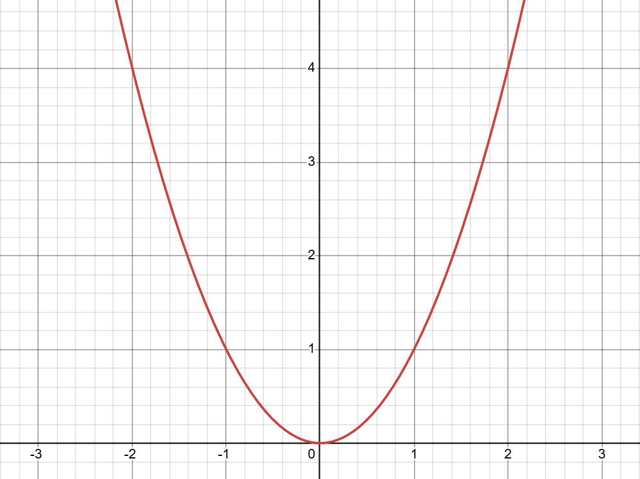

We have to find the slope from the given point…
- P(1, 1), Q(2, 4)
Therefore, we will use the formula… m = Δy ÷ Δx
y = 4 – 1 = 3
x = 2 – 1 = 1
By dividing y with x (3 ÷ 1) together, we get… m = 3
Now, we can use e.q
- y - y₁ = m( x - x₁ )
To use the formula, we plug in P into the equation
- y – 1 = 3(x – 1)
- y = 3x – 3 + 1
- y = 3x – 2

The answer… “y = 3x – 2” is the answer for Step 1

Step 2
Find an e.q of the line passing through pts P(1, 1) and Q(1.1, 1.21). Basically, we are now calculating the point P and reducing Q’s values.
- Note: We have to move point Q closer to point P. In the following steps (Steps 2 – 4), we will only manipulate point Q. Notice how in Step 2, P remains, but Q changed.
- Basically, we repeat what we did in Step 1, but this time: our point Q is different.
Now…

We have to find the slope from the given point…
- P(1, 1), Q(1.1, 1.21)
  - To find the new Q(1.1, 1.21), we need to move closer to P(1, 1). This is done by copying P, and adding 0.1. For the y plug-in, it needs to be squared because it has to stay in the parabola. In short, Q(1.1, 1.21) is basically Q(1.1, (1.1)^2)
Therefore, we will use the formula… m = Δy ÷ Δx
y = 1.21 – 1 = 0.21
x = 1.1 – 1 = 0.1
By dividing y with x (0.21 ÷ 0.1) together, we get… m = 2.1
Now, we can use the e.q
- y - y₁ = m( x - x₁ )
To use the formula, we plug in P into the equation
- y – 1 = 2.1(x – 1)
- y = 2.1x – 2.1 + 1
- y = 2.1x – 1.1

The answer… “y = 2.1x – 1.1” is the answer for Step 2

The red represents the parabola, which is the e.q y = x²
The blue is the line of Step 2’s equation

Step 3
- This is a repeat of step 2, but instead of adding +0.0 1 to P Q, it will be 0.01. This is basically making Q approach P further.

P(1, 1), Q(1.01, (1.01)²) P(1, 1), Q(1.01, 1.0201)
- y = 1.0201 – 1 = 0.0201
- x = 1.01 – 1 = 0.01
- m = 2.01
We’ve now found the slope. Let’s put this in a y=mx+b formula.
- y – 1 = 2.01(x – 1)
- y – 1 = 2.01x - 2.01
- y = 2.01x – 1.01

Step 4
- This is a repeat of step 3, but instead of adding +0.01 to P Q, it will be 0.001. This is basically making Q approach P further.

P(1, 1), Q(1.001, (1.001)²) P(1, 1), Q(1.001, 1.002001)
- y = 1.002001 – 1 = 0.002001
- x = 1.001 – 1 = 0.001
- m = 2.001
We’ve now found the slope. Let’s put this in a y=mx+b formula.
- y – 1 = 2.001(x – 1)
- y – 1 = 2.001x – 2.001
- y = 2.001x – 1.001

Step 5
Now, we have to guess. Based on the previous Steps 2 – 4, we can conclude that Q approaches P. Therefore, we must…
- Guess what the formula is by how Q is being approached.
We started with…
- y = 3x – 2
And ended with…
- y = 2.1x – 1.1, y = 2.01x – 1.01, y = 2.001x – 1.001, y = 2.0001x – 1.0001, etc.
Thus, our tangent line must be…
- y = 2x – 1

2nd Metrhod
The textbook argues that…
- Instead of “indefinitely” re-calculating the slope closer to “guess” the tangent line, there is another way to prove this efficiently with derivatives.
- Point P remains as is, but Q will be manipulated. This is a much efficient method in finding the tangent line.

This is the most confusing part. Basically, we now implement the concept of “h” to simplify our steps 2 – 4.

Imagine that…
- h = 1
- h = 0.1
- h = 0.01
- h = 0.001
- h = 0.0001
  - and so – on…

All of this can be best simplified into the variable h h.
Thus, instead of finding m by re-calculating x and y multiple times, we can do this formula…
Q = (1 + h, (1 + h)²)

Basically, the idea…
- Q(1 + h, (1 + h)²)
Can be found by…
- P(P₁, P₂) Q(P₁ + h, (P₁ + h)²)

So for example, if…
- P(P₁, P₂) P(2, 4)
Then…
- P(2, 4) Q(2 + h, (2 + h)²)

Let’s implement limits. But I believe it’s better to explain why we need limits.
Granted that the equations above bring Q to P closer each iteration. The problem is, if Q eventually becomes P, then it is undefined.
Limits allow us to ask, “What does the slope approach as Q get infinitely close to P?”

We notice here that… (1 + h)² exists inside Q. Let’s expand it by using this formula:
- (a + b)² = a² + 2(a)(b) + (b)²
Thus, making this…
- 1² + 2h + h².
We are not done yet, however, as we have to find the new slope.
Remember, the formula to get the slope is Δy ÷ Δx
- y = (1 + h)² - 1² = 1² + 2h + h² -1²
  - The 1’s crosses out, so we’re left with…
    - 2h + h²
- x = (1 + h) – 1 = h
  - x = h
- m = y/x
  - (2h + h²) ÷ (h)
    - m = 2 + h

Then, let’s apply this formula again:
- y - y₁ = m( x - x₁ )
We can do this by using our unchanged P(1, 1), while using 1² + 2h + h² as our slope.
- The 1² is still 1, so we don’t have to include it in.
  - y – 1 = (2 + h) ( x – 1)
  - y – 1 = (2 + h)x – (2 + h)
  - y = (2 + h)x – (1 + h) This is the generalization of steps 2 and 4.
Now, the limits.
New formula to remember: lim x
x x

To apply, turn y to lim.
- lim(2 + h)x – (1 + h)
h 0
These are two terms, so we must also add lim after the x
lim(2 + h)x – lim(1 + h)
h 0 h 0
Think of this as…
    - lim(2 + h)x = 2x
h 0
    - lim(1 + h) = 1
h 0

- The final answer is…
  - lim(2 + h)x – lim(1 + h) = 2x - 1
h 0 h 0

Some things to remember… (for y=x²)
- When trying to find the limit of a formula. For this scenario, to y=x²
  - P(P₁, P₂) Q(P₁ + h, (P₁ + h)²)
  - Then, find m by
    - m = Δy ÷ Δx
      - y = (P₁ + h)² - P₁
      - x = P₁ + h - P₁
  - Next, use
    - y - y₁ = m( x - x₁ )
  - After, replace y with lim, and separate the two terms together.

